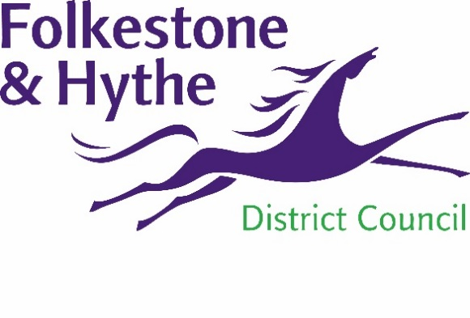
NEWS RELEASE

6 October 2021

VIBRANT PLAN FOR FOLKESTONE
TOWN CENTRE IS TAKING SHAPE
The “grand challenge” of ensuring a sustainable and vibrant future for Folkestone town centre has been fully embraced by councillors.
Cabinet members have approved the Place Plan and, at the same time, agreed to apply for funding to the Government’s Levelling Up Fund – a £4.8 billion initiative providing grants to support capital investment projects across Britain.
Members were told that while Folkestone already has much to celebrate, there is work to be done to build on this to ensure the town centre continues to adapt and diversify moving forward to meet its changing role.
To address the challenges ahead, Folkestone and Hythe District Council has worked with partners and communities to develop the Place Plan, which sets a vision and direction for the town centre, including opportunities for new infrastructure investment.
In response to the council’s declaration of a climate emergency, sustainability is at the heart of the Place Plan, alongside improvements to transport and movement in the town centre, and sites which could be repurposed or developed.
Six ‘missions’ have been developed in response to specific challenges identified in the plan, under the title of The Grand Challenge. These are: to celebrate what’s good, a town centre for the future, a place for all voices, moving sustainably, access to opportunity, and to deliver sustainable quality.
The action to deliver these missions is grouped geographically: the station arrival, Sandgate Road (West), the town centre, Creative Quarter, coastal area and Heritage Quarter, Harbour and Sunny Sands. The council is committed to ongoing engagement with partners and local communities as projects are developed and delivered across the action areas.
Cllr David Wimble, Cabinet Member for the District Economy, said: “The Grand Challenge sets a bold and overarching target for the future of the town centre and is intended to create a clear pathway to attain sustainable and inclusive growth led by public, private and voluntary sectors.
“Some of the actions, especially those with a longer timescale, are highly aspirational and not necessarily within the control of the council, or its responsibility. There is, however, a clear leadership role for us to ensure that the overall ambition in the plan is pursued vigorously.”

ENDS
Notes to Editors
For more information, please email communications@folkestone-hythe.gov.uk

Follow us on Facebook: @FolkestoneandHytheDC
Follow us on Twitter: @fstonehythedc
Follow us on Instagram: @folkestonehythedc
Follow us on LinkedIn: Folkestone & Hythe District Council

